LC#1423 MAXIMUM POINTS YOU CAN OBTAIN FROM CARDS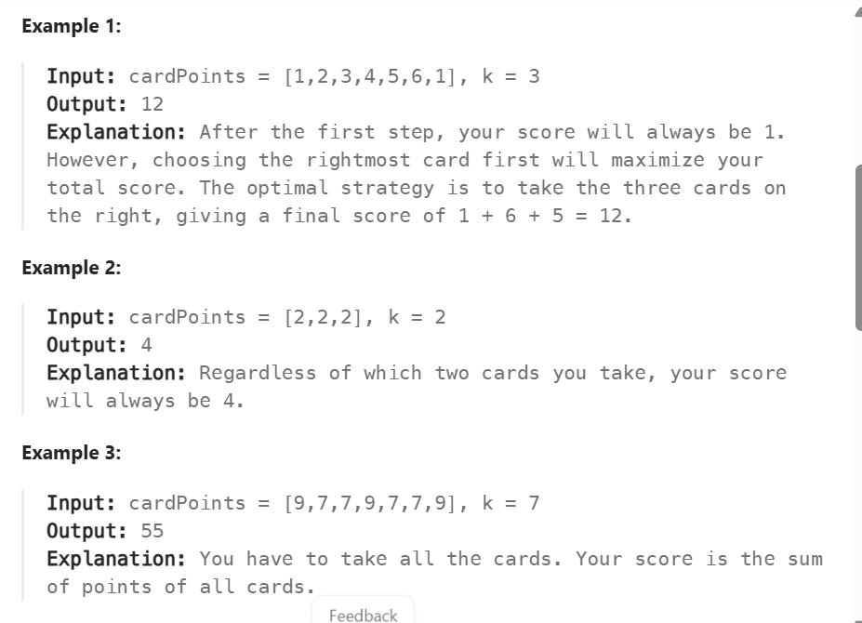
APP: TC:O(K+K) SC:O(1)
->first calculate the sum 0 ->first k elements
->reduce left and take that from right
->alter the k—and right—until k reaches 0
CODE:
class Solution {
public int maxScore(int[] c, int k) {
int lsum = 0 ;
for(int i = 0 ; i<k ; i++)
lsum+=c[i];
int maxSum = lsum;
for(int i = c.length-1;k>0;i--)
{
lsum = lsum +c[i]-c[--k];
maxSum = Math.max(maxSum , lsum);
}
return maxSum;
}}

